Q1 : Write a Java program to create a new array list, add some elements (string) and print out the collection by using a for-each loop. (10 Marks)

ANSWER :-

import java.util.ArrayList;

public class QUE1 {
public static void main(String[] args) {
ArrayList<String> myInfo = new ArrayList<>();
myInfo.add("i");
myInfo.add("am");
myInfo.add("Saurabh...");
myInfo.add("and");
myInfo.add("i play");
myInfo.add("Football.");

for(String S : myInfo){
System.out.println(S);
}
}
}
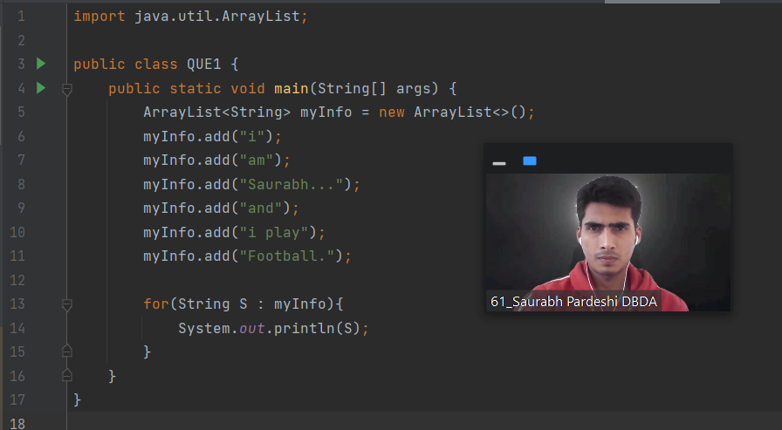

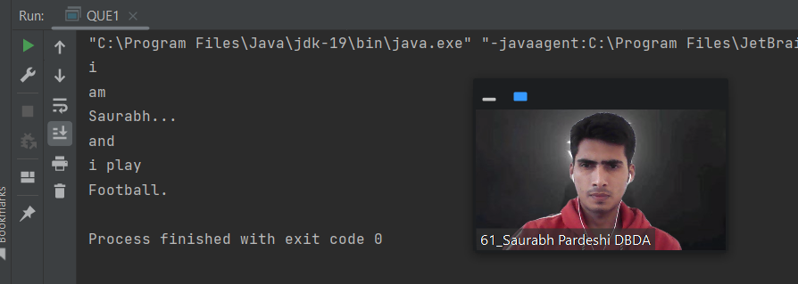

Q3 : Write a program to create a class named shape. In this class we have three subclasses: circle, triangle and square, each class has two member functions named draw () and erase (). Create these using Runtime Polymorphism concepts. (10 Marks)

Answer:-
import java.awt.*;
public class Shape {
void draw(){
System.out.println("Draw Shapes");
};
void erase(){
System.out.println("Erase Shape");
}
}
class Circle extends Shape{
@Override
void draw(){
System.out.println("Draw Circle");
}
@Override
void erase(){
System.out.println("Erase Circle");
}
}
class triangle extends Shape{
@Override
void draw(){
System.out.println("Draw Triangle");
}
@Override
void erase(){
System.out.println("Erase Triangle");
}
}

class Square extends Shape{
@Override
void draw(){
System.out.println("Draw Square");
}
@Override
void erase(){
System.out.println("Erase Square");
}
}
class Result{
public static void main(String[] args) {
Shape C = new Circle();
C.draw();
C.erase();
Shape T = new triangle();
T.draw();
T.erase();
Shape S =new Square();
S.draw();
S.erase();
}
}
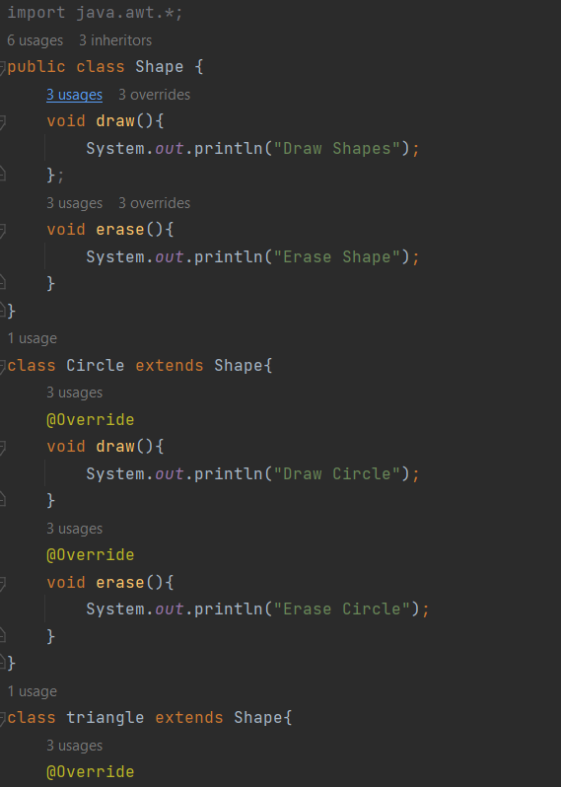
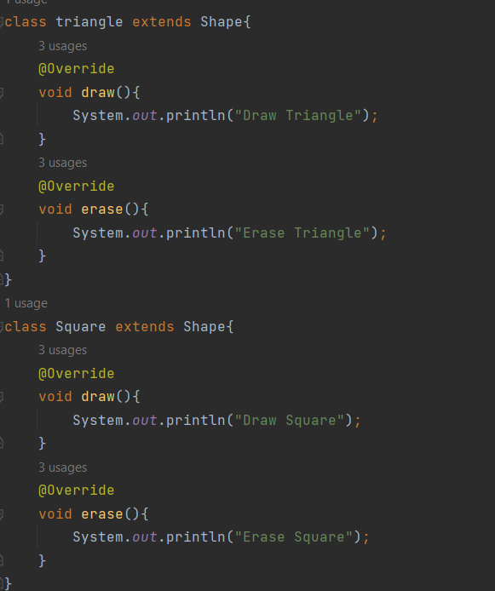

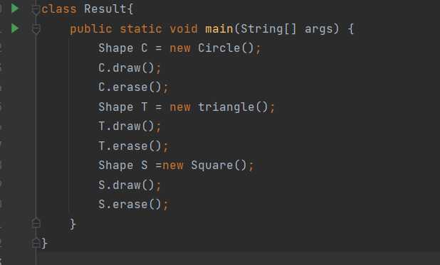

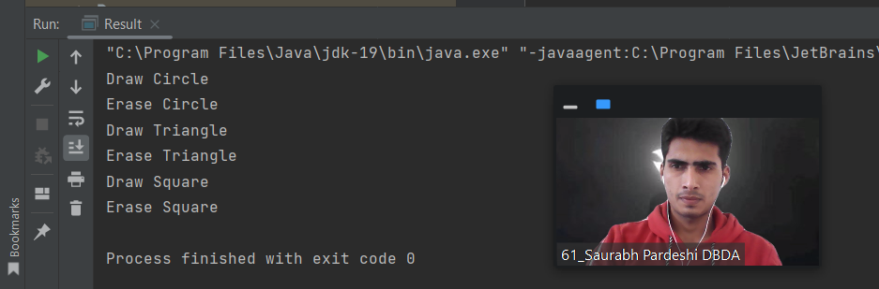

Q4 : Constructor chaining (10 Marks)

Answer:-
class Grandparents{
String grandFatherName;
String grandMotherName;

Grandparents(String x, String y) {
grandFatherName = x;
grandMotherName = y;
System.out.println("Grandfathers Name : "+grandFatherName);
System.out.println("Grandmothers name : "+grandMotherName);
}
}
class Parents extends Grandparents{
String FatherName;
String MotherName;

Parents(String x, String y, String s, String r) {
super(x, y);
FatherName = x;
MotherName = y;
System.out.println("Fathers Name : "+FatherName);
System.out.println("Mothers Name : "+MotherName);
}
}
class Child extends Parents{

Child(String x, String y, String s, String r) {
super(x, y, s, r);
}

public static void main(String[] args) {
Child C = new Child("GrandFather","GrandMother","Father","Mother" );
}
}

